**Database Fundamentals**

**196. Step 01 - Getting Started with Databases**

Here we will talk high level on the database

* Databases provide organized and persistent storage for your
* data
* To choose between different database types, we would need to understand:
* Availability
* Durability
* RTO (Recovery Time Objective)
* RPO (Recovery Point Objective)
* Consistency
* Transactions etc
* Let's get started on a simple journey to understand these

**197. Step 02 - Understanding Challenges with Choosing Databases**

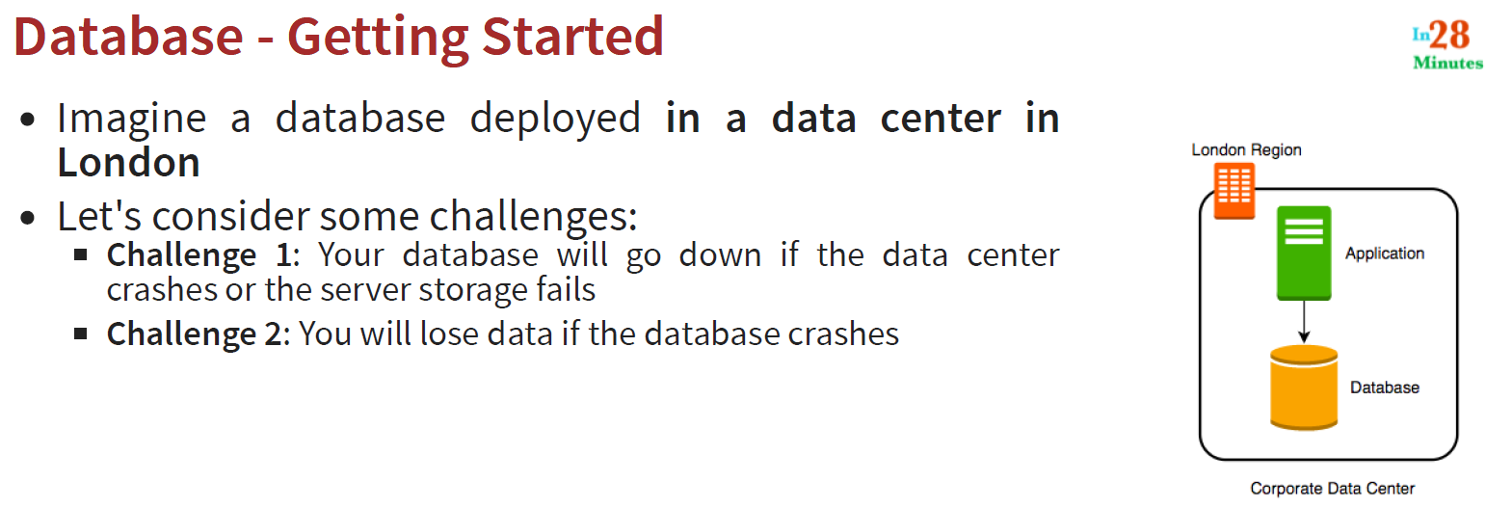

Here challenge 1 and 2 looks like same but, challenge -1 talk about the connectivity and challenge 2- talks about data availability.

**Solution: We will have to add database snapshots.**

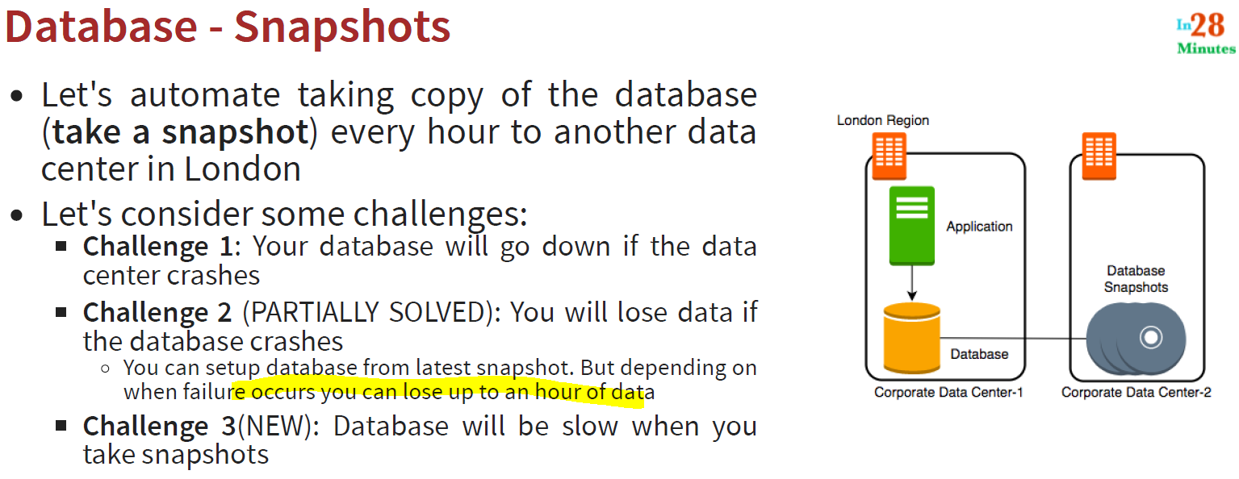

So introducing taking snapshot does not solve the first challenge but it resolve the challenge 2 partially because we keep taking database backup and we can restore the database with this snapshot backups.

But snapshot brings one additional challenge also i.e. it makes the database slow because on the first hand it process the data into database and on the other hand it take the backup also.

**So what is the alternative?**

**Solutions:**

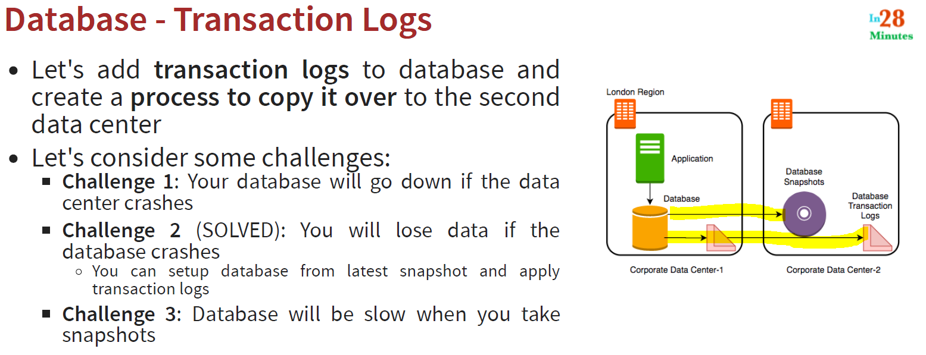

**Transaction Logs: it is nothing but, those changes which happened to database since the time the last database snapshot has happened.**

**So challenge 2 is completely solved but still challenge 3 is persist.**

**Solution:**

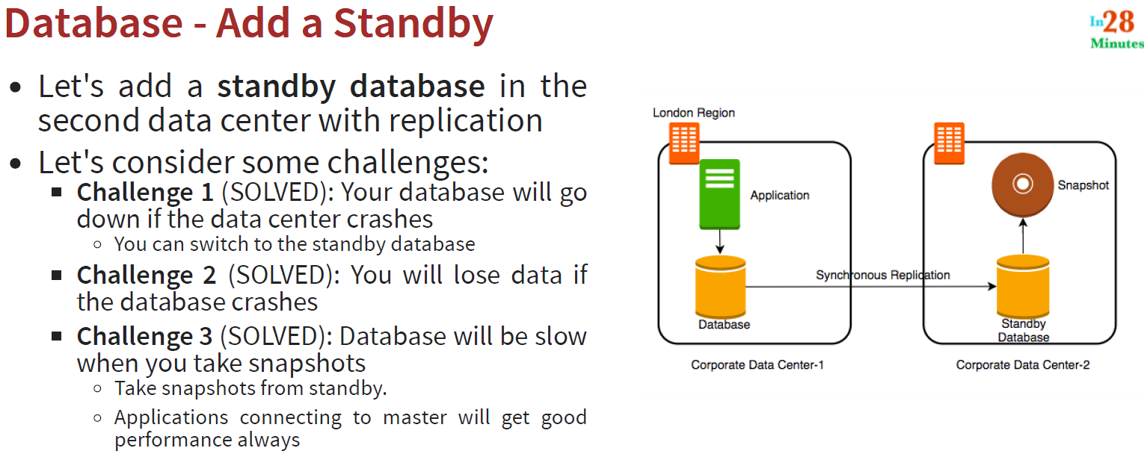

So will add a standby database at the corporate data center with a synchronous replication and we can see challenge 1 is solved, if database 1 is down then we can immediately switch to standby database.

Challenge 2 is also got solved 100% because here instead of taking snapshot as backup every hour we keep taking backup with a synchronous replication.

Challenge 3 is also solved because now there is now snapshot is being taken as backup from stand by so it is like Master and slave structure.

Note: The intention from this discussion to aware about the challenges that we can face while choosing database, solution could be anything as there no perfect solution so far.

**198. Step 03 - Understanding Availability and Durability of Databases**

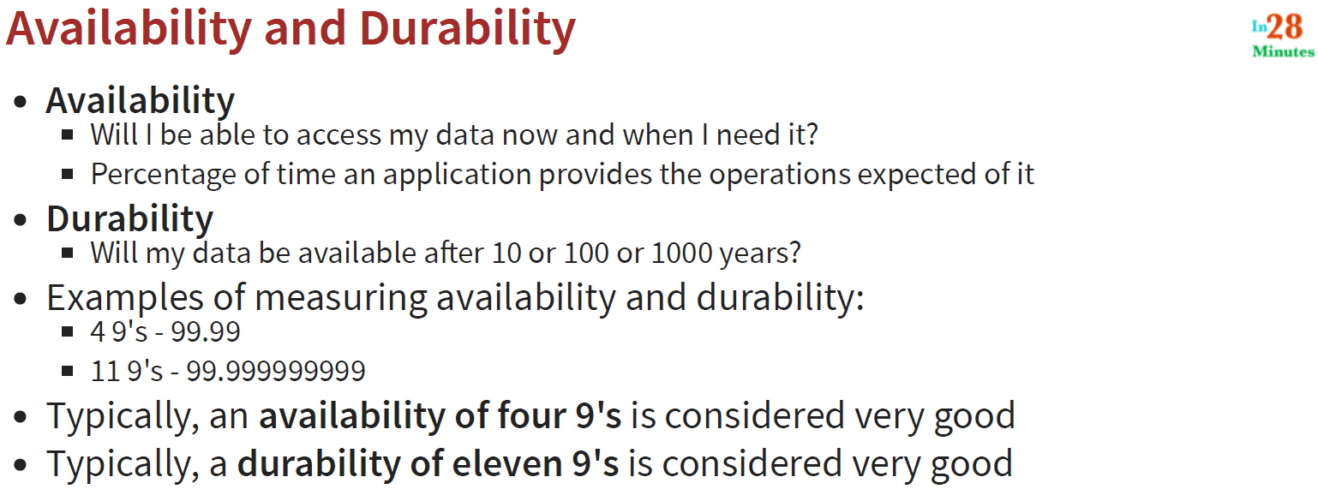

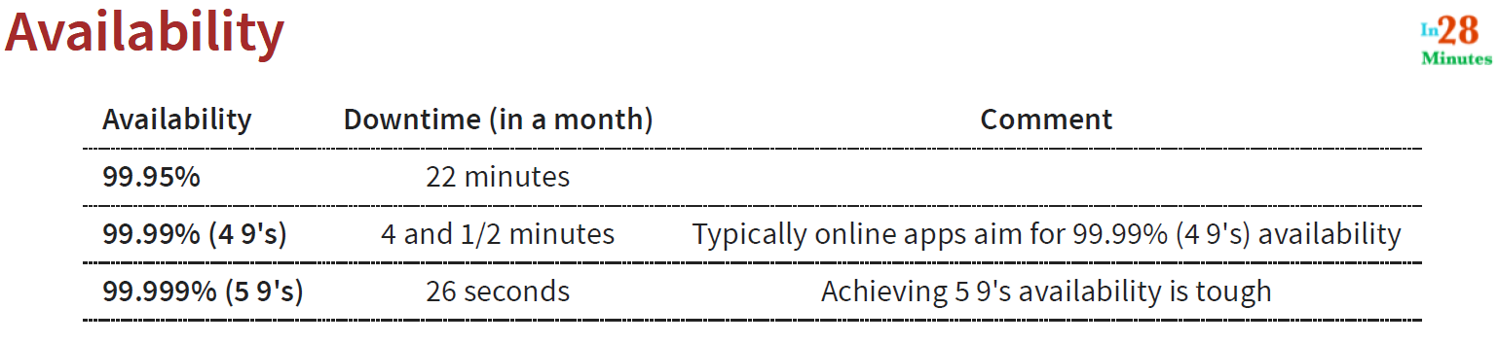

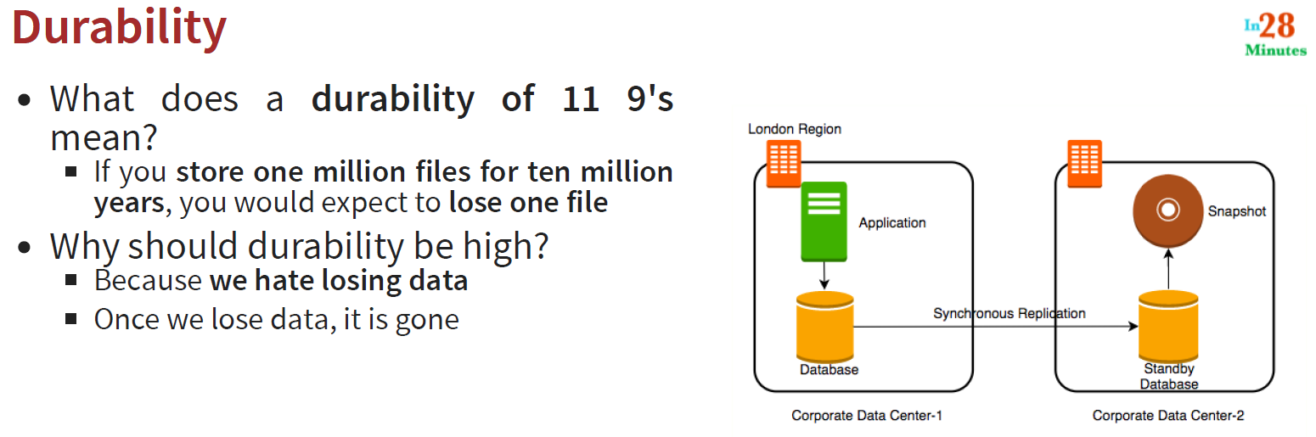

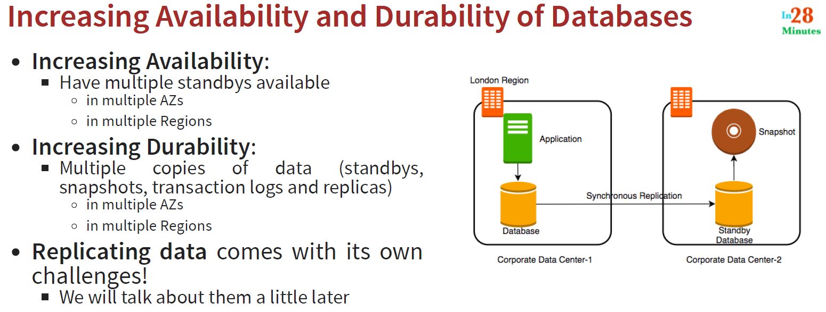

**199. Step 04 - Understanding RTO and RPO**